 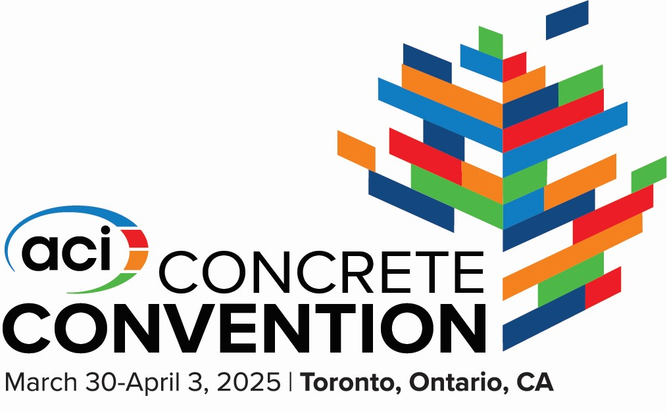

Remittance Form

Company Name___________________________________________________

Contact Name_____________________________________________________

Address__________________________________________________________

Telephone________________________________________________________

E mail___________________________________________________________

Credit Card # ___________________________ Exp__________CCV________

**Contribution Level Contribution Amount**

32 MPa (Lanyards) $25,000.00

30 MPa (Concrete Mixer) $25,000.00

25 MPa (Opening Reception) $10,000.00

20 MPa (Trade Show Booth) $7,500.00

15 MPa (Student Lunch) $5,000.00

10 MPa (Student Bus) $2,000.00

1 MPa (Chapter Supporter) $1,000.00

Please make your cheque payable to ACI - Ontario Chapter

2220 Stir Crescent, Mississauga, Ontario, L4Y 3V3